1. Resolve Merge Conflicts
Create a merge conflict intentionally (two users editing the same line
Objective
Learn how Git handles conflicts when two people edit the same line.
Scenario
Two branches modify the same line in a file.
Step 1: Create repository
mkdir merge-conflict-demo
cd merge-conflict-demo
git init
Step 2: Create initial file
echo "Hello from main branch" > app.txt
git add .
git commit -m "Initial commit"
Step 3: Create feature branch
git checkout -b feature
Step 4: Go back to main branch
git checkout master
Step 5: Merge feature branch
git merge feature

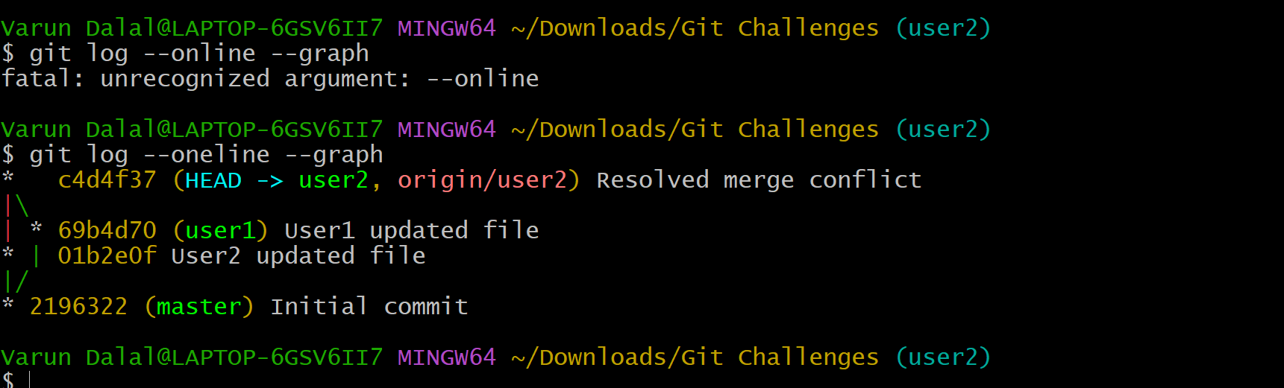

2. Recover Deleted Branch-
- Delete a local branch and then recover it using the reflog.
- Create branch
- git checkout -b testing
- Add file:
- touch test.txt
git add .
git commit -m "Testing branch commit"
- Delete branch
- Move to master:
- git checkout master
- Delete:
- git branch -D testing
- Recover branch
- Check reflog:
- Recover:
- git checkout -b testing a1b2c3d
- Validation
- git branch

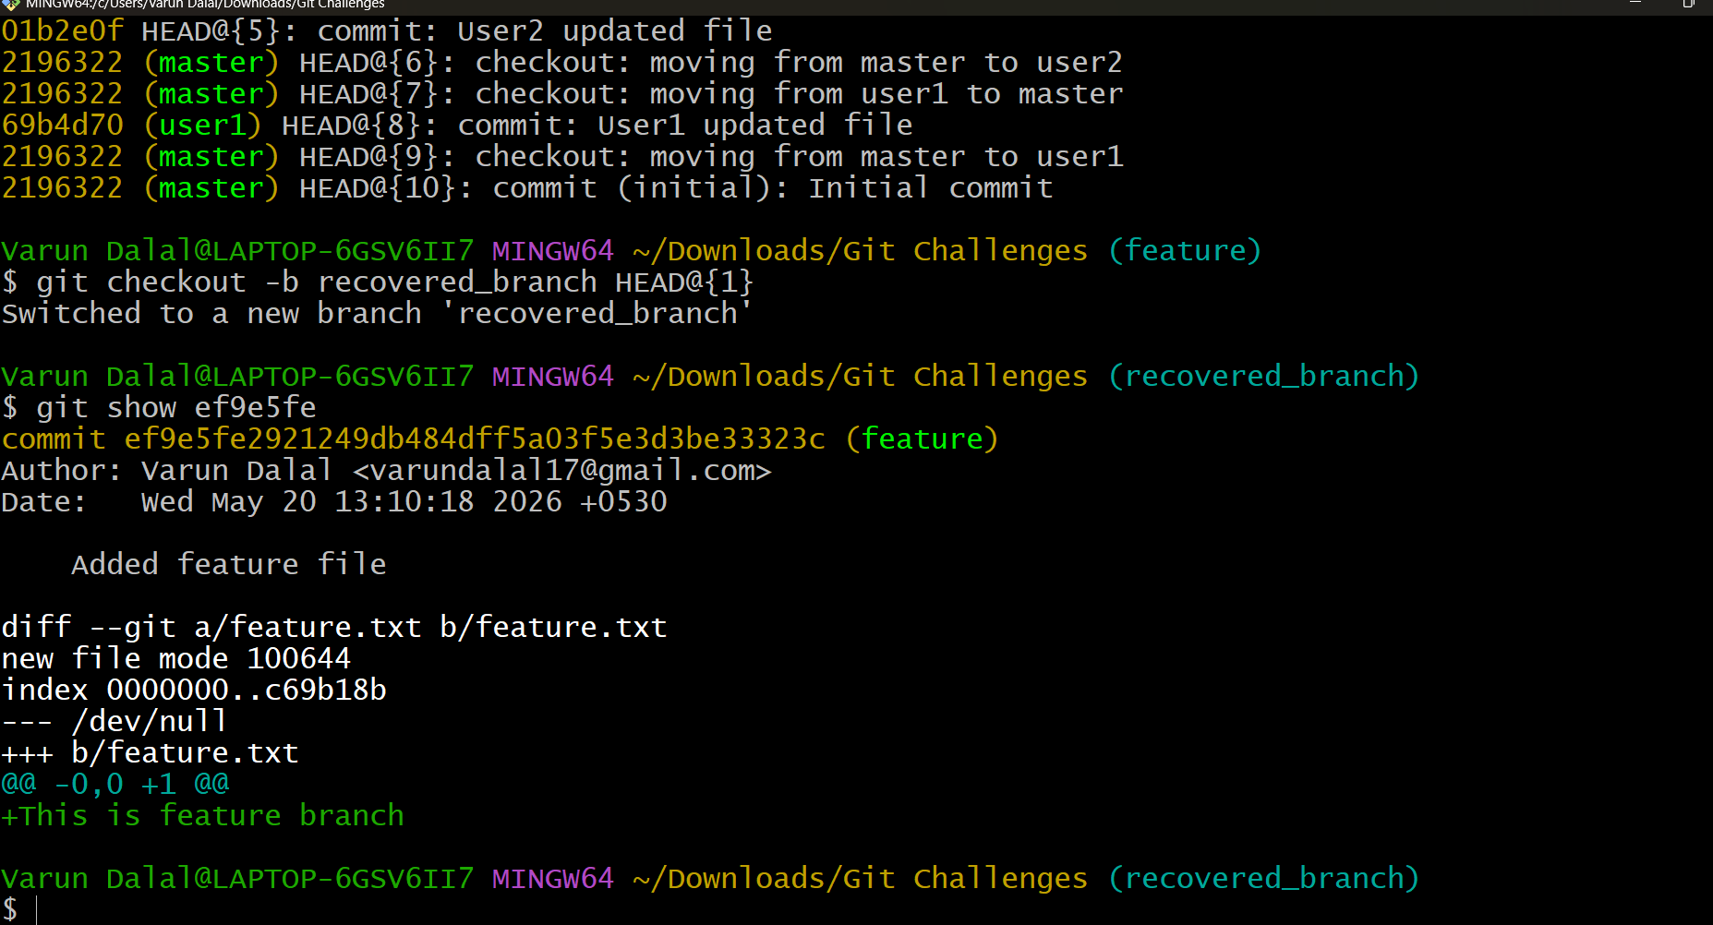

3. Undo Wrong Push
- Push a wrong commit to GitHub, then undo it without losing history
- Steps
- Create wrong commit
- echo "Wrong code" > wrong.txt
git add .
git commit -m "Wrong commit"
- Push:
- git push origin master
- Undo safely using revert
- git revert HEAD
- Git opens editor.
- Save and exit.
- Outcome
- Wrong changes are removed but history remains safe.
- Validation
- git log --oneline
- You will see:
- Revert "Wrong commit"
Wrong commit
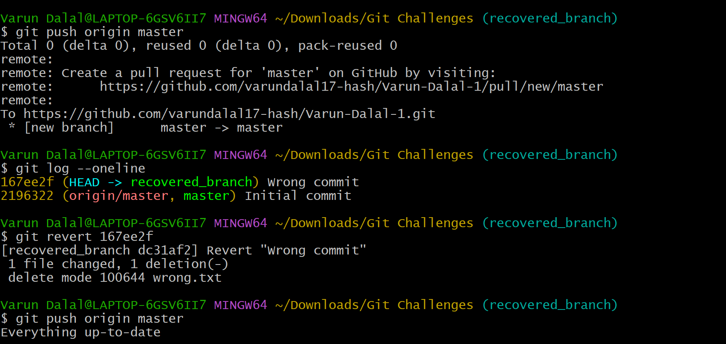

4. Make a commit, then add a missing file to it usinggit commit –amend
Objective
Add forgotten file into previous commit.
Steps
Create files
echo "Main file" > app.txt
git add .
git commit -m "Added app file"
Forgot another file:
echo "Config file" > config.txt
Add missing file
git add config.txt
Amend:
git commit --amend
Outcome
Previous commit updated instead of creating new commit.
Validation
git log --oneline
Only one commit exists with both files.

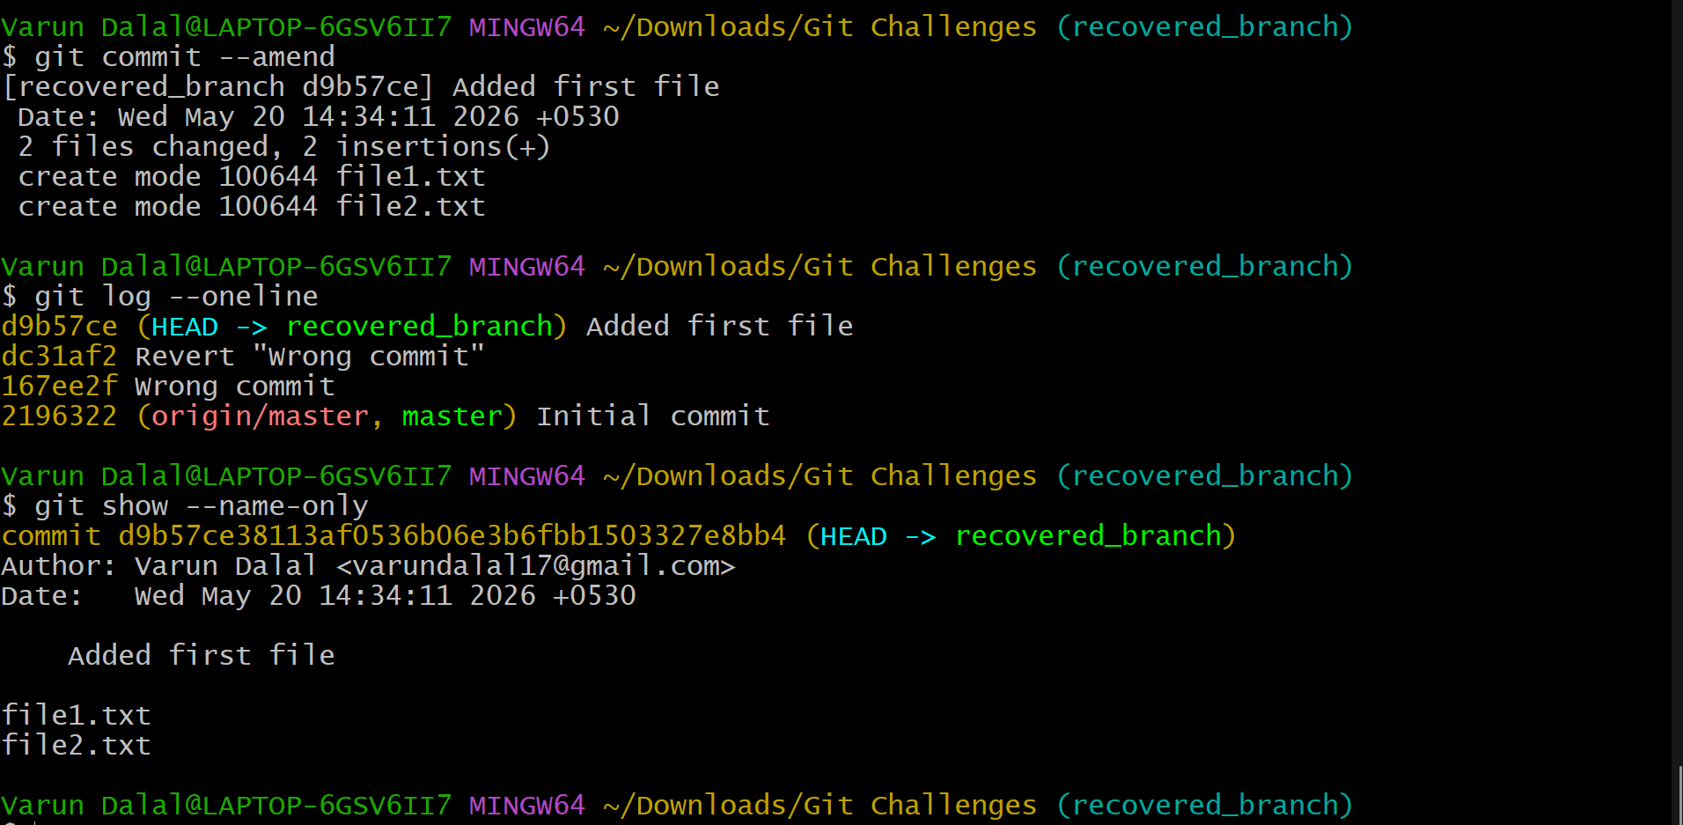

5. Take a specific commit from one branch and apply it to another branch
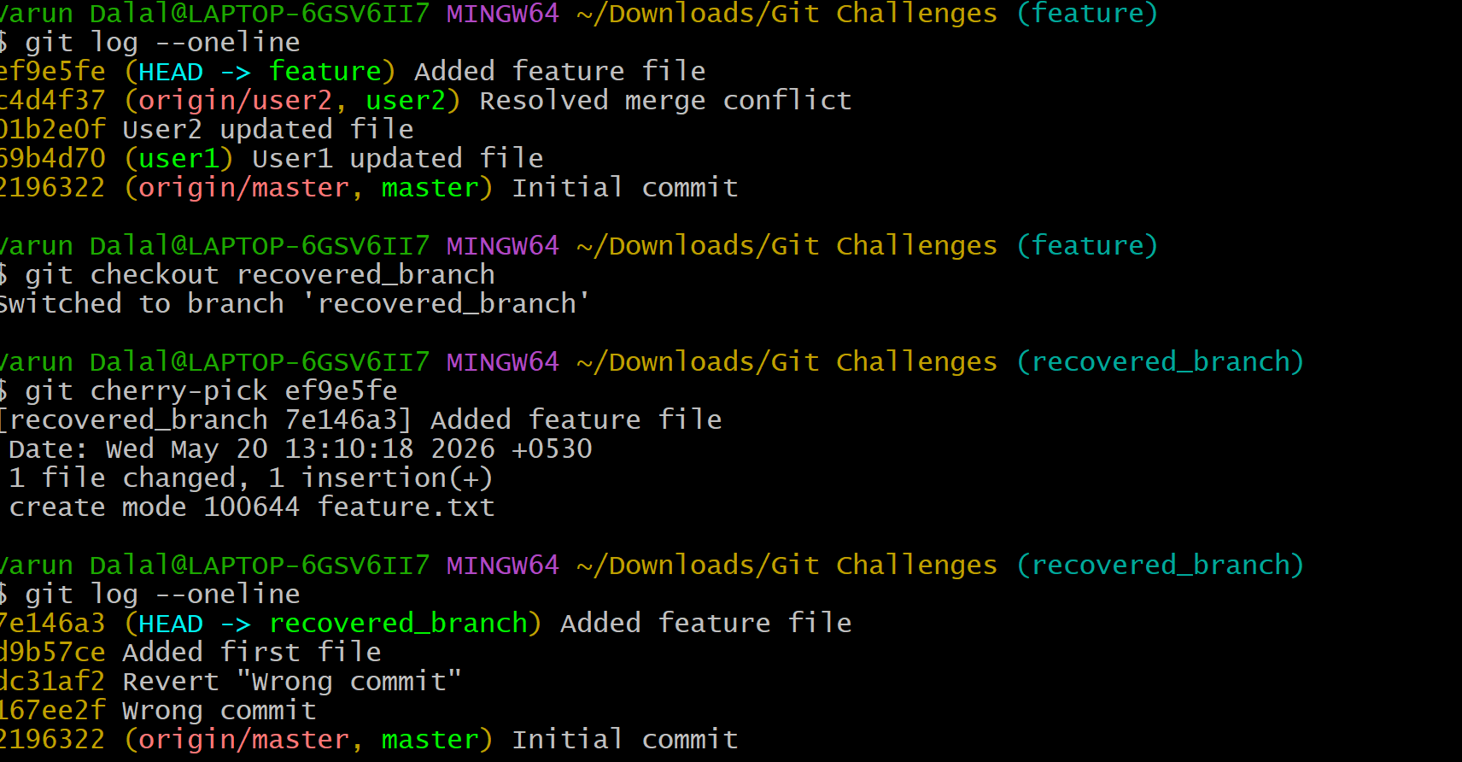
Objective
Copy one specific commit from one branch to another.
Steps
Create branch
git checkout -b feature
Create commit:
echo "Feature work" > feature.txt
git add .
git commit -m "Feature commit"
Get commit hash:
git log --oneline
Move to master
git checkout master
Cherry-pick:
git cherry-pick abc1234
Validation
git log --oneline
Feature commit appears in master.

6. Interactive Rebase
- Reorder and squash multiple commits into a single clean commit

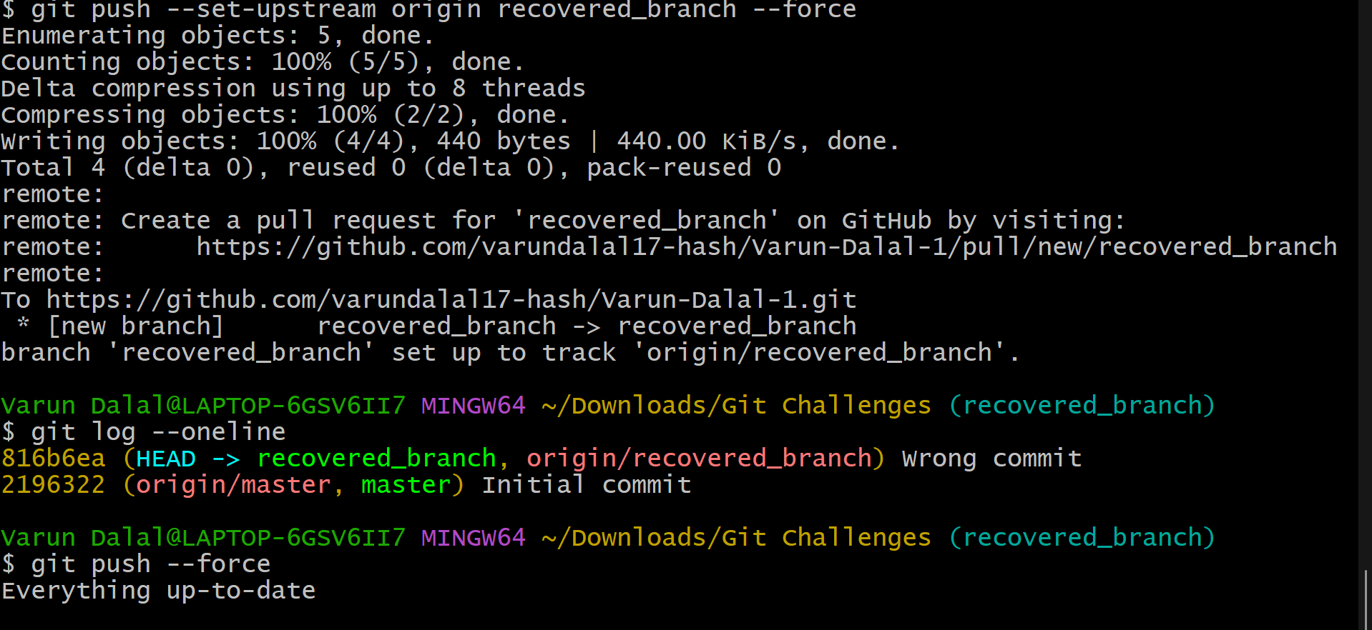
Objective
Combine multiple commits into one clean commit.
Steps
Create commits:
echo "1" > file.txt
git add .
git commit -m "Commit 1"
echo "2" >> file.txt
git add .
git commit -m "Commit 2"
echo "3" >> file.txt
git add .
git commit -m "Commit 3"
Start rebase
git rebase -i HEAD~3
Editor opens:
pick aaa111 Commit 1
pick bbb222 Commit 2
pick ccc333 Commit 3
Change to:
pick aaa111 Commit 1
squash bbb222 Commit 2
squash ccc333 Commit 3
Outcome
Three commits become one.
Validation
git log --oneline
Only one commit appears.

7. Tagging & Release
- Create a version tag (v1.0), push it to GitHub, then delete and restore it.

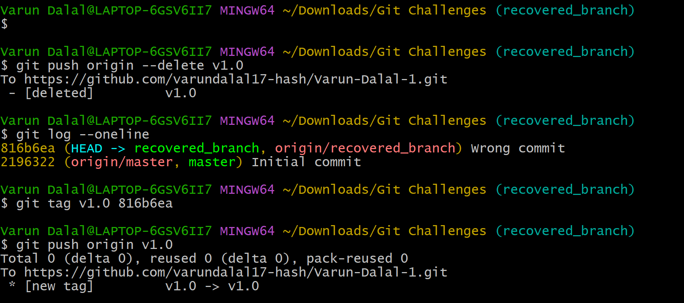
Objective
Create and manage release tags
Create Tag
git tag v1.0
Push Tag
git push origin v1.0
View Tags
git tag
Delete Local Tag
git tag -d v1.0
Delete Remote Tag
git push origin --delete v1.0
Restore Tag
git tag v1.0
git push origin v1.0

8. Clone with Sparse Checkout
- Clone only a subdirectory of a repo using sparse checkout
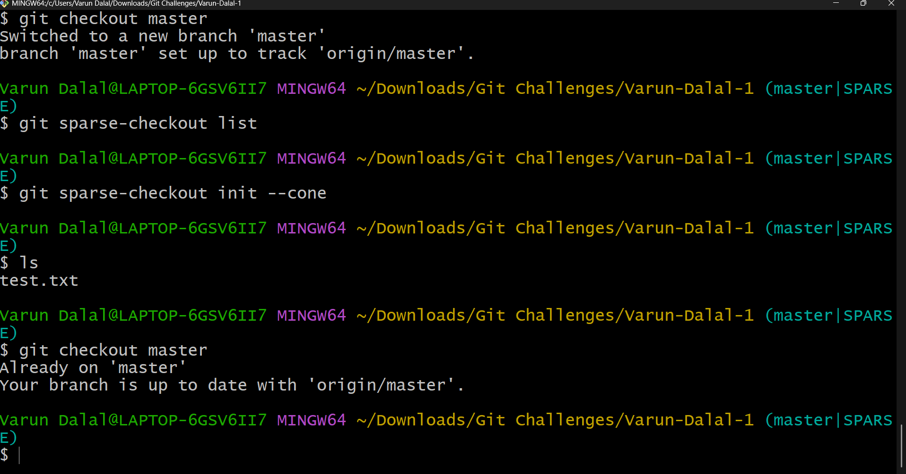
Objective
Download only one subdirectory.
Steps
git clone --no-checkout <repo-url>
cd repo-name
Enable sparse checkout:
git sparse-checkout init --cone
Select folder:
git sparse-checkout set src
Checkout:
git checkout master
Outcome
Only src folder downloads.

9. Reset vs Revert Challenge
Demonstrate the difference betweengit reset --hardandgit revertin a repo
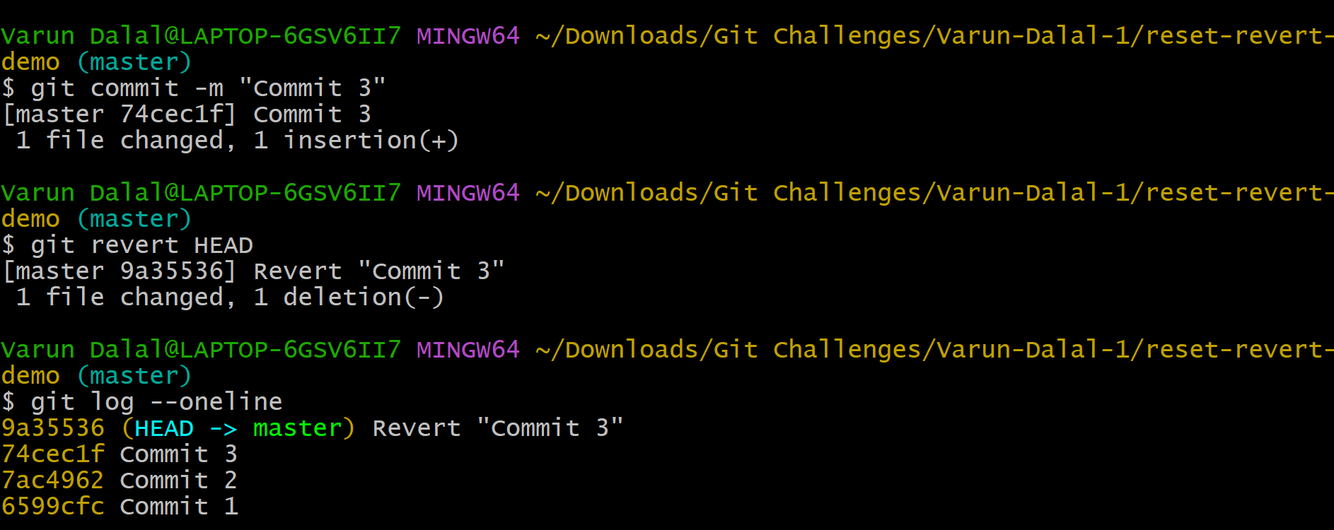
Objective
Understand difference between reset and revert.
Create commit
echo "Testing" > test.txt
git add .
git commit -m "Testing commit"
Reset Example
git reset --hard HEAD~1
Outcome
- Commit removed
- Changes deleted
- History rewritten
- Revert Example
- Create again:
- echo "Testing" > test.txt
git add .
git commit -m "Testing commit"
- Now revert:
- git revert HEAD
Outcome
- Commit history preserved
- New reverse commit created
- Validation
- git log --oneline

10. Detached HEAD Challenge
- Checkout a specific commit (detached HEAD state) and create a new branch from it.

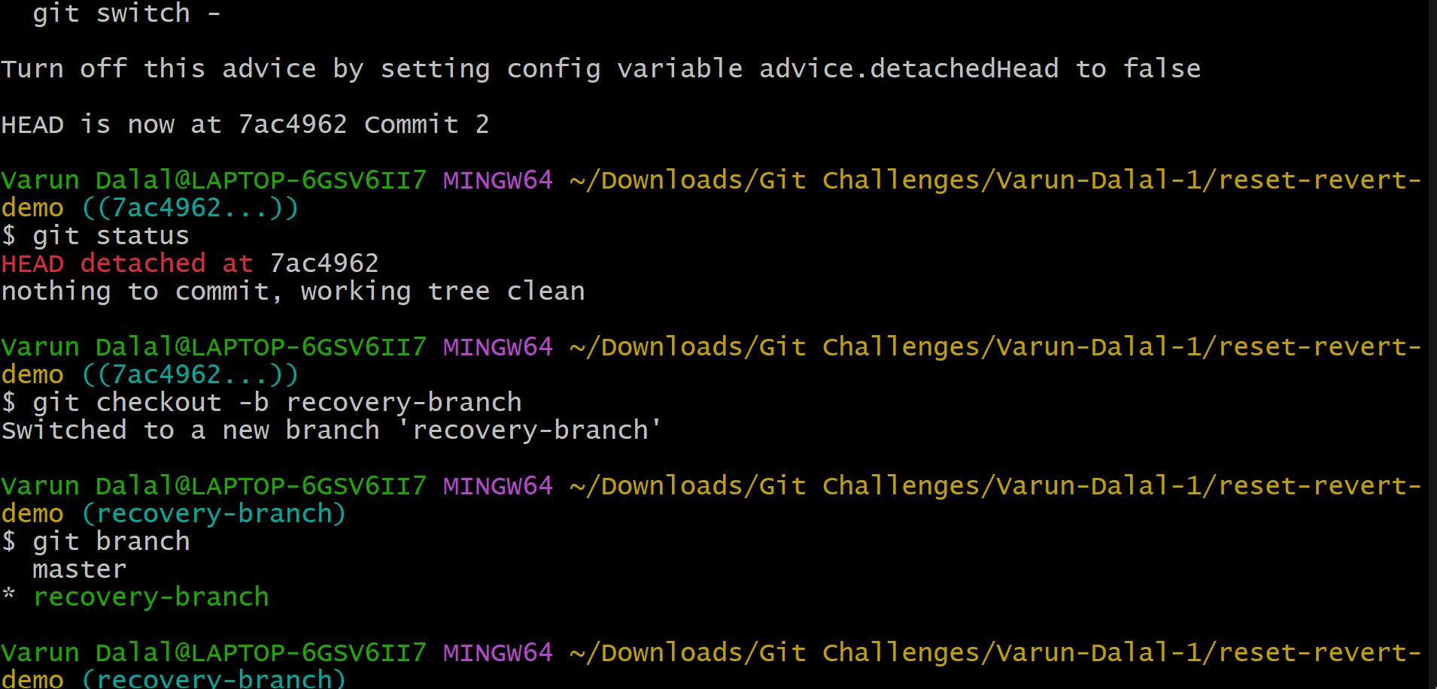
Objective
Work from old commit safely.
teps
View commits:
git log --oneline
Checkout old commit:
git checkout abc1234
Git shows:
You are in 'detached HEAD' state
Create new branch
git checkout -b recovery-branch
Validation
git branch

11. Git Hooks Challenge
- Configure apre-commithook to reject commits without a message format (e.g., must start withJIRA-XXX
- Objective
- Reject invalid commit messages.

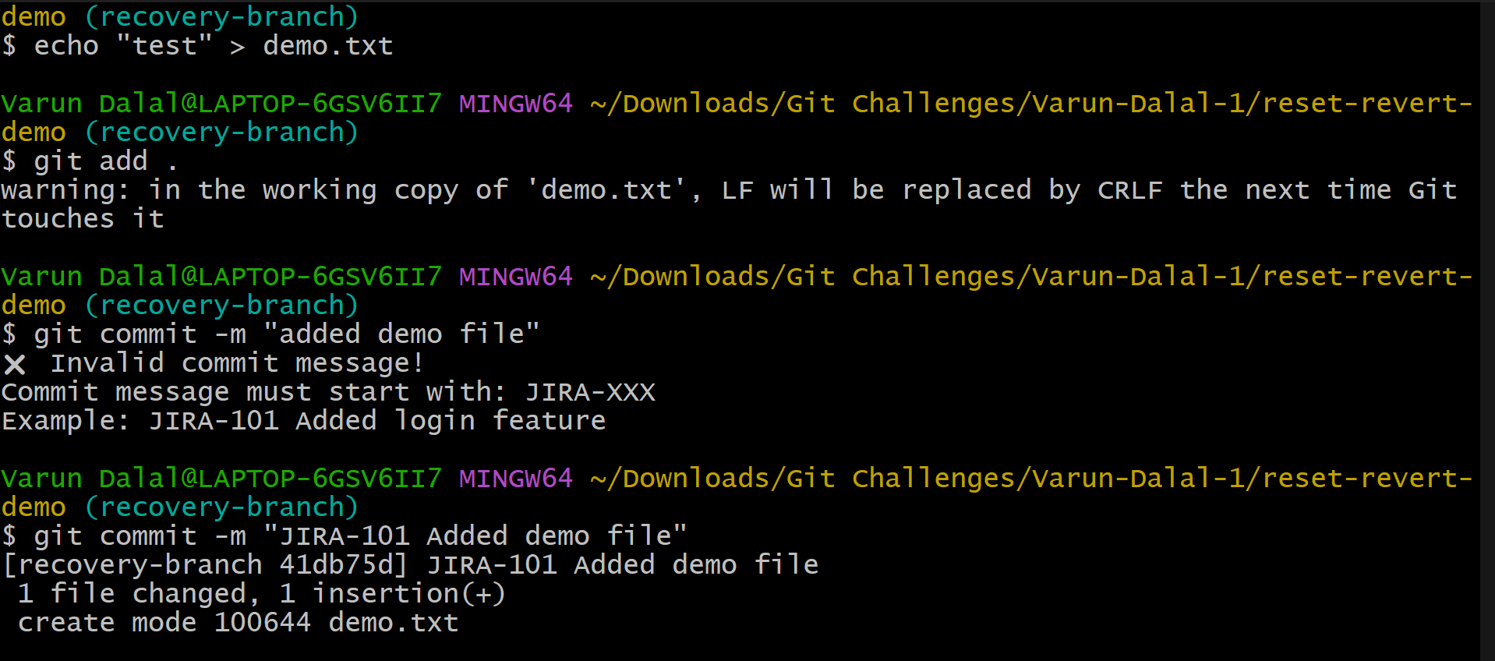
Create hook
Go to hooks folder:
cd .git/hooks
Create file:
vi commit-msg
Add Script
#!/bin/bash
commit_msg=$(cat "$1")
if [[ ! $commit_msg =~ ^JIRA-[0-9]+ ]]
then
echo "Commit message must start with JIRA-XXX"
exit 1
fi
Give permission
chmod +x commit-msg
Test Wrong Commit
git commit -m "fixed bug"
Rejected.
Correct Commit
git commit -m "JIRA-101 fixed bug"
Accepted.

12. Squash Merge vs Rebase Merge
- Show the difference between squash merge and rebase merge with evidence
- Squash Merge
- Feature branch commits
- git checkout -b feature
echo "1" > a.txt
git add .
git commit -m "Commit 1"
echo "2" >> a.txt
git add .
git commit -m "Commit 2"
- Squash merge
- git checkout master
git merge --squash feature
git commit -m "Squashed feature changes"
- Outcome
- One combined commit only.
- Rebase Merge
- Reset example repo.
- Create commits again.
- Rebase:
- git checkout feature
git rebase master
- Merge:
- git checkout master
git merge feature
- Outcome
- Original commits preserved in linear history.
- Validation
- git log --oneline --graph

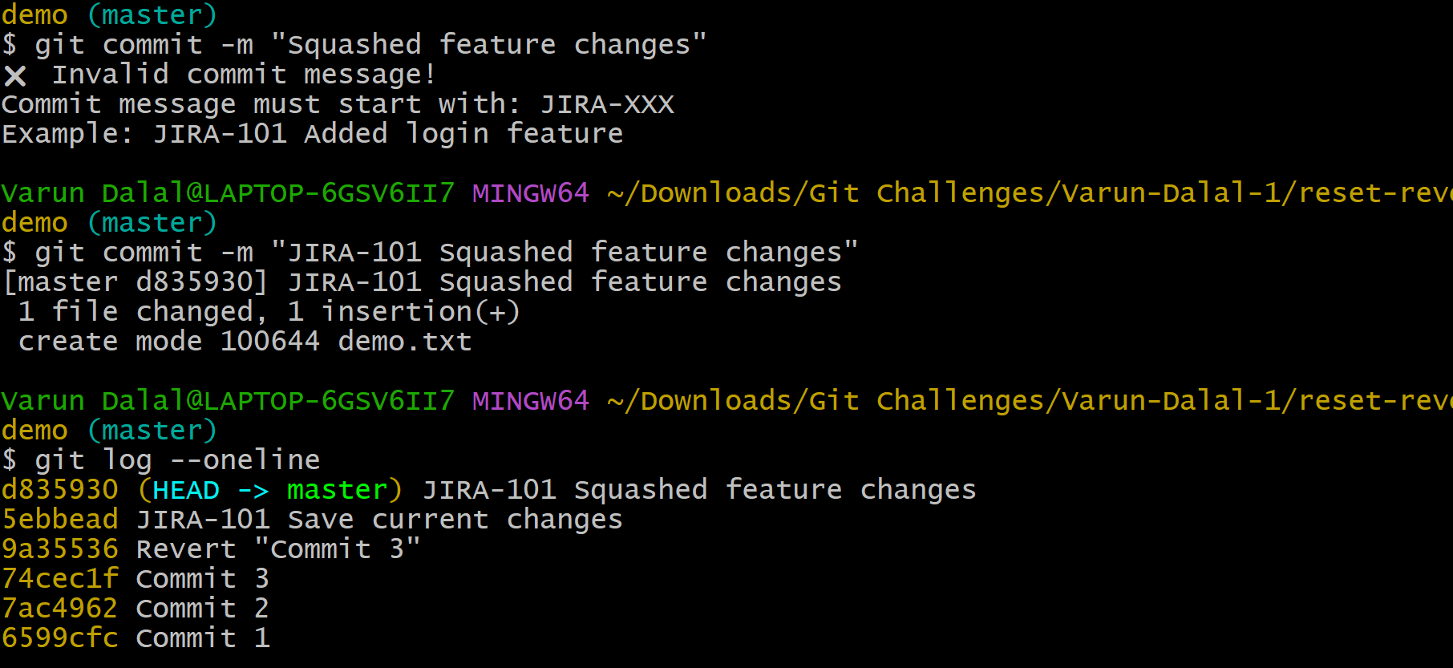

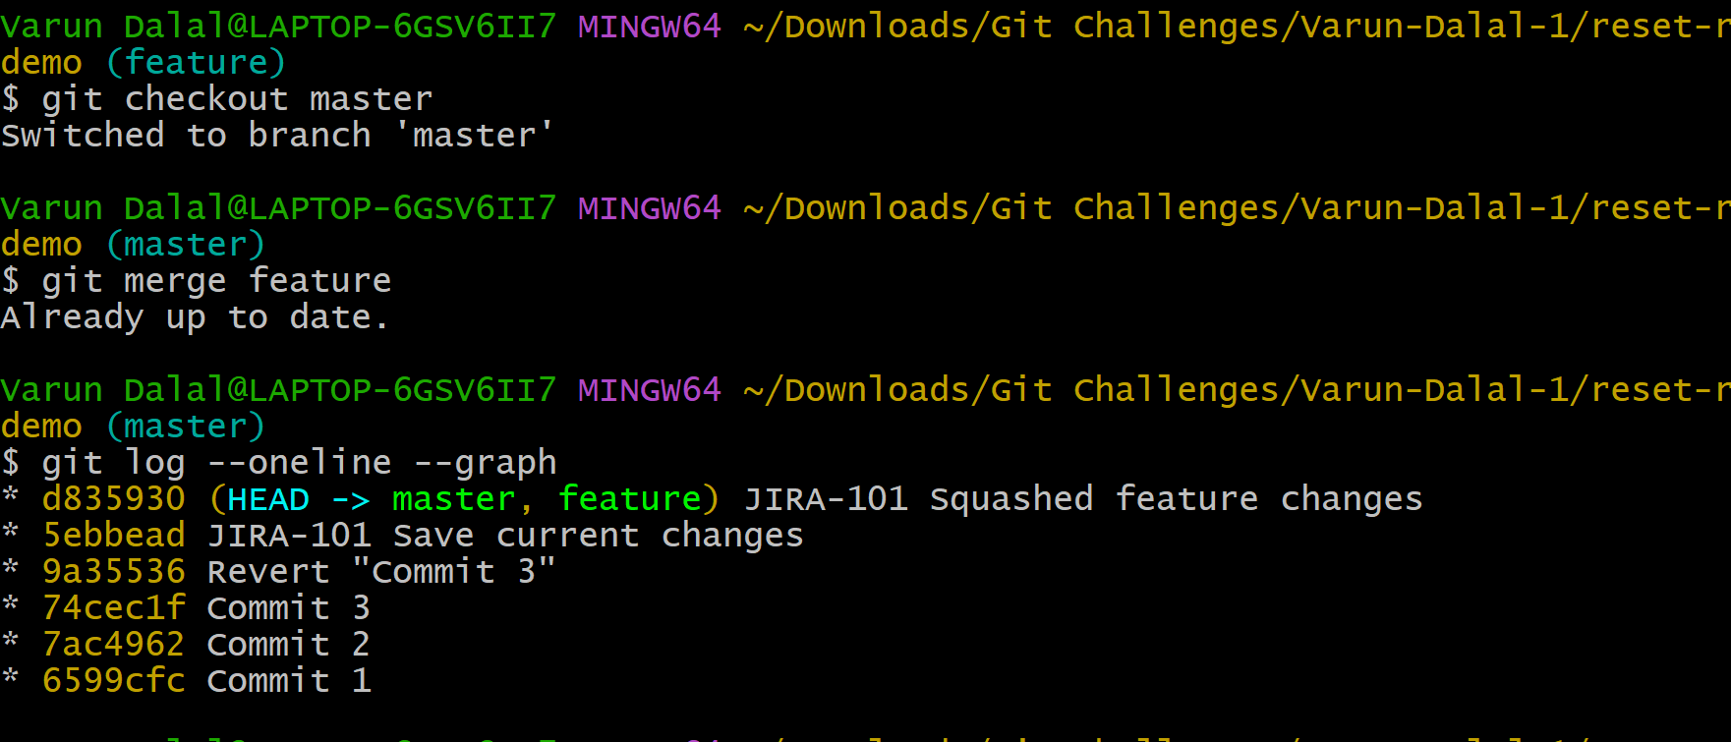

13. Fork & Pull Request Workflow
- Fork a repo, make a change, and submit a pull request to the original repo
- Objective
- Contribute to another repository.
- Steps
- Fork repository on GitHub
- Click:
- Fork
- Clone fork
- git clone <your-fork-url>
- Create branch
- git checkout -b feature-update
- Make changes
- echo "Updated" >> README.md
- Commit:
- git add .
git commit -m "Updated README"
- Push:
- git push origin feature-update
- Create Pull Request
- Go to GitHub.
- Click:
- Compare & pull request

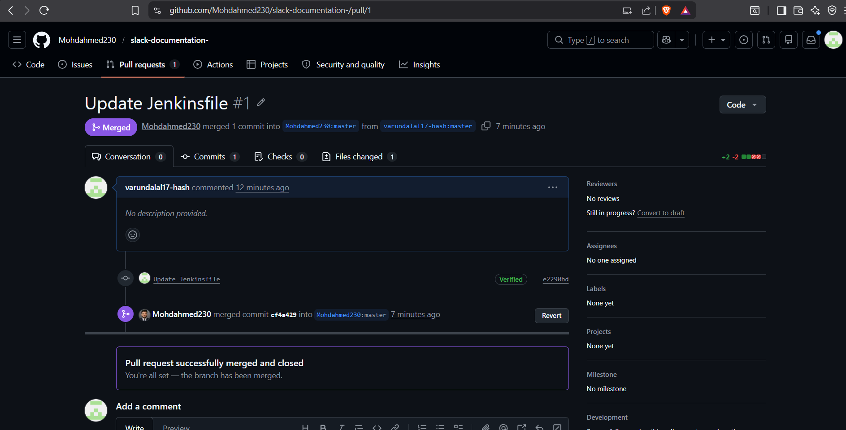
14. Recover Lost Commit
- Commit something, reset hard, and then recover it usinggit reflog.
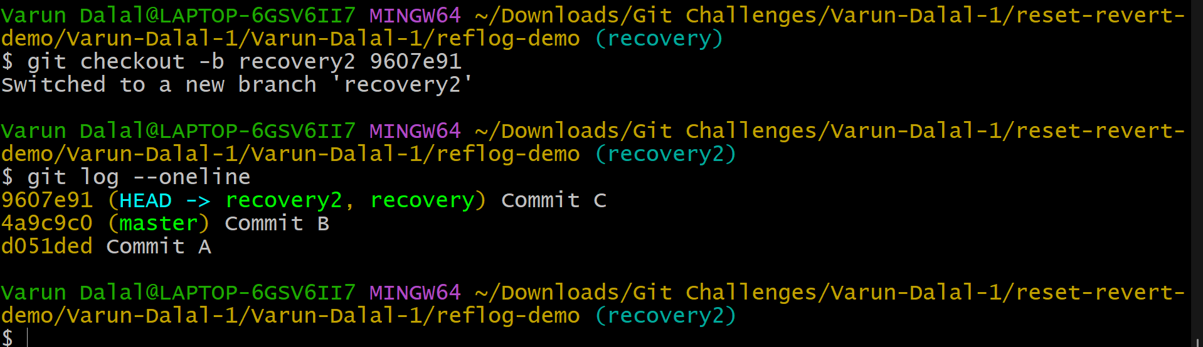
Objective
Recover commit after hard reset.
Steps
Create commit:
echo "Important data" > important.txt
git add .
git commit -m "Important commit"
Delete commit
git reset --hard HEAD~1
Commit disappears.
Recover using reflog
git reflog
Recover:
git checkout -b recovered-work abc1234
Validation
ls

